Users’ Guide

Latin-to-Cham Script Transliteration
Jim Brase, NRSI, 2015

Overview
This document addresses two activities related to the Latin to Cham transliteration process:
- Running the Latin-to-Cham transliteration software to create/update the Cham-script text.
- Maintaining and updating the Latin-to-Cham Spelling dictionary.

File locations and extensions
description | location | file extension
Latin-script Paratext files | C:\My Paratext Projects\Cham | .SFM
Cham-script Paratext files | C:\My Paratext Projects\ChamScr | .SFM
Spelling Conversion Software | C:\My Paratext Projects\ChamSpConv
Temporary files | C:\My Paratext Projects\ChamTemp

Running the transliteration process
- Locate the Latin-script Paratext project folder. (i.e. C:\My Paratext Projects\Cham).
  - Find the shortcut icon 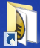 labeled My Paratext Projects on the desktop, and double click on it.
  - Open the Cham folder.
- Locate the 000 Latin to Cham script - Shortcut located at the top of the folder. Do not click on it.
- Also locate the .SFM file for the book that you want to convert to Cham script. Highlight it, but do not double click.
Filenames will use the pattern ddXYYCHAM.SFM, where dd is a two-digit book number, and XYY is a three character abbreviation for the book name. XYY may be a string of three letters, or one digit (1, 2, or 3 for 1st, 2nd, or 3rd) followed by two letters.
- Drag and drop the .SFM file onto the shortcut.
- The Cham-script file will be placed in the folder C:\My Paratext Projects\ChamScr.

Maintaining the Latin-to-Cham Spelling Dictionary
The Latin-to-Cham spelling dictionary is named L2cDict.ods, and is located in the folder C:\My Paratext Projects\ChamSpConv. Any words which do not follow the normal spelling rules must be entered into this dictionary.

Position and size windows for editing the dictionary
Although the dictionary can be edited at any time, you may find it particularly convenient to edit it while proofreading the Cham-script text. To do that, arrange the windows on your screen as shown here:
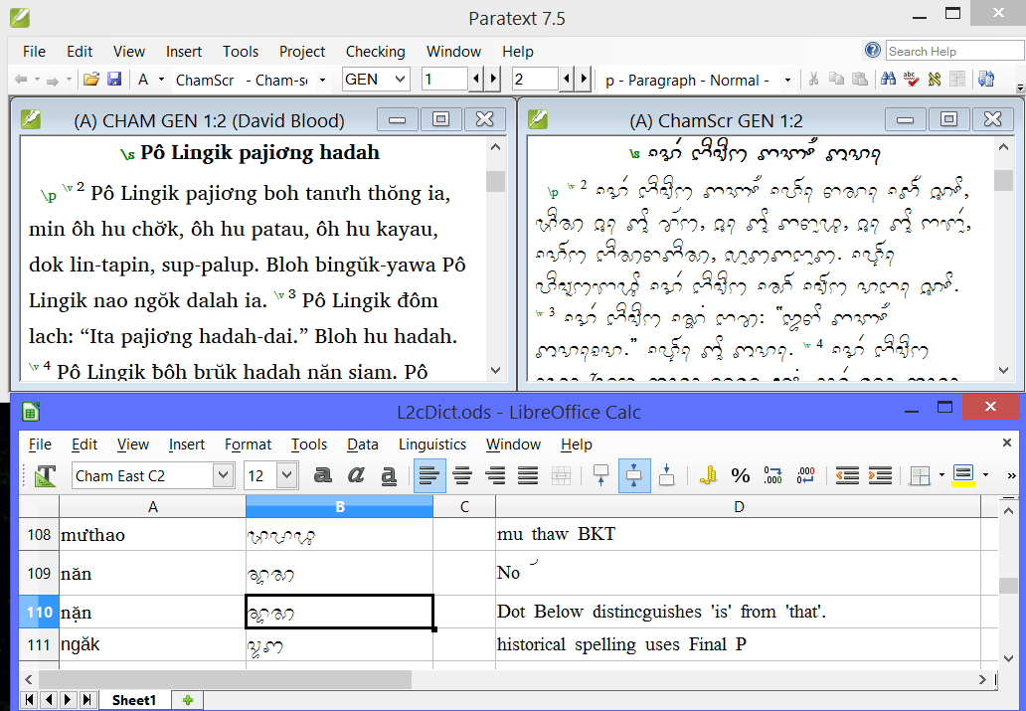
The window at the top left is the Latin text in Paratext. At the top right, the Cham text, also in Paratext. The dictionary file is underneath these. This arrangement allows you to compare what’s in the Cham script with what’s in the Latin text, and edit the dictionary as necessary.
To arrange your windows in this way, follow these steps:
- Right click on the LibreOffice Calc icon on the task bar¹. You will see a menu that looks something like this:
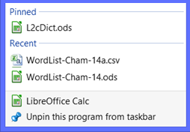
Left click on L2cDict.ods². This is the dictionary file.
- Position and size the dictionary window to use the bottom half (approximately) of the screen.
- Launch Paratext by clicking once on the Paratext icon on the task bar³.
- Position and size the window to use the top half of the screen.
- If they are not already open, open both the Cham Latin-script project and the Cham Cham-script project.
  - If the Latin-script project is not open, Press Control-O, then select “CHAM” from the list of projects.
  - If the Cham-script project is not open, Press Control-O, then select “ChamScr” from the list of projects.
- Place your cursor in the Latin-script project window.
- Click on Window / Tile vertical.

Notes:
¹ If the LibreOffice Calc icon is not shown on the taskbar, locate the Edit Latin-to-Cham dictionary or Edit L2C dictionary icon on your desktop and drag it to the taskbar. Release the icon when you see the popup notice “Pin to taskbar”.
² If L2cDict.ods² is not shown in this menu, follow the same procedure as for Note 1.
³ If the Paratext icon is not shown on the task bar, locate the Paratext icon on the desktop, and drag it to the task bar. Release the icon when you see the popup notice “Pin to taskbar”.

Dealing with spelling errors in the Cham text
When you encounter a spelling error in the Cham text, follow the steps below:
- Make a note of where the spelling error is located, so you can easily relocate it and check it after it is corrected.
- Is the Latin source text spelled correctly?
- If there is an error in the Latin text: Correct the Latin, and rerun the spelling conversion.
  - Never edit the Cham-script text directly in Paratext. Any such edits will be lost the next time the transliteration process is run.
- If the Latin text is correct, go to #2.
- Is the word already in the spelling dictionary?
If it is, make sure it’s correct.
- Add the word and the correct spelling to the dictionary.
- Rerun the spelling conversion process now or after you’ve made more corrections.
If the word is already spelled correctly in the spelling dictionary, but is still not coming out correctly in the Cham text, notify the program author.

Editing the dictionary
- The order of the entries is not essential for the functioning of the spelling program, but they will be easier to locate and edit if they are kept in alphabetical order. Create entries in alphabetical order by the Latin spelling.
- To insert a blank row, place the highlight at the point where you want to make the insertion, and click on the “insert row” icon 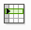 in the toolbar (or click on the Insert/Row command on the menu bar).
- Columns:
  - Enter the Latin spelling in the first column.
  - Enter Cham spelling in the second column.
  - Normally leave the “status” (3rd) column blank. You can enter ON, but it’s not necessary. If you are uncertain about a dictionary entry, and want to disable it without deleting it (i.e. to make it easy to recover later), enter OFF in the status column.
  - You are encouraged to use the “Comment” column to keep a record of why this word needs to be in the dictionary. (E.g. “Uses Big P”).

Saving the dictionary file
- Simply press Control-S, or click on the Save icon.

Appendix—data flow diagram
Proofreading
and
Editing
Cham script text
C:\My Paratext Projects\ChamScr
Spelling dictionary
C:\My Paratext Projects\ChamSpConv
Latin script text
C:\My Paratext Projects\CHAM
Dictionary Substituion
Rules-based Transliteration
Script Conversion Process

